WHO are we? Shooting Stars Nursery School officially opened on 14th January 2020. We are enjoying getting to know parents and children and finding our feet in the local community. We work with children aged 2-4. Our manager, Clare Wilkins is a qualified teacher and has worked with children aged 3-11 for the past 22 years. She has been a senior leader in schools for over 10 years. Our deputy manager, Marika Groce has worked with pre-school aged children for over 20 years and has a degree in Childhood Studies. Both are passionate about making a difference in the lives of children and families.
WHERE are we? We are at Old Down Hall, 364 Kempshott Lane, Basingstoke, RG22 5UY.
WHAT makes us different? We plan in the moment with children in order to capture times when they are already really engaged with their play as this is when children learn best. We don’t pre-plan activities which will interrupt and draw them away from what they’re doing. Instead, we provide a wide variety of different hands on learning activities daily and wait to see what individual children decide to do. We then play alongside them and they learn as they play.
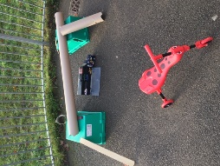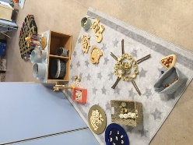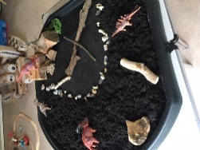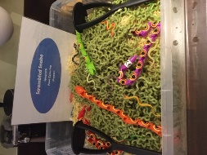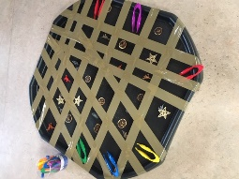
WHY should you send your child here? We are a small setting and know our children really well. This enables us to teach the children their next steps on the go as they’re playing. We believe in developing the whole child so that they are emotionally and physically ready for school aged 5. We work on developing a growth mindset so that children grow up with the belief that they can do anything they want to, they just need to keep trying. Teaching children to manage their emotions is also really important to us as this will equip them well for their next steps as they begin school and will enable them to flourish academically.
WHEN are we open? We are open daily 8am-4pm during term time (possibly holidays too as we grow). We serve hot lunches between 12 and 1pm and offer breakfast if required to children arriving between 8 and 8.45am.HOW do I find out more? Contact us on 07900600243. Find us on Facebook – Shooting Stars Nursery School. Visit our website – shootingstarsnurseryschool.co.uk. Email us at shootingstarsnurseryschool@gmail.com . Book an appointment to view us in action and have a chat about how we can make a difference to your child’s future.

